|  |  |  |  |
| --- | --- | --- | --- |
|  |  |  | **’ r\*** |
| **■ufer**  **Cl** ’?‘'tiB | **F-**  **- *k jfl** | **■ * ** H**  **M B** | **Jf aK^^^V/ ^B** |

|  |  |  |  |  |  |
| --- | --- | --- | --- | --- | --- |
|  |  | , ® >JR | | Ite | & |
|  |  |  |  |  |  |
|  |  |  | j L-»M E*T* L-j 11-3 J |  | I |

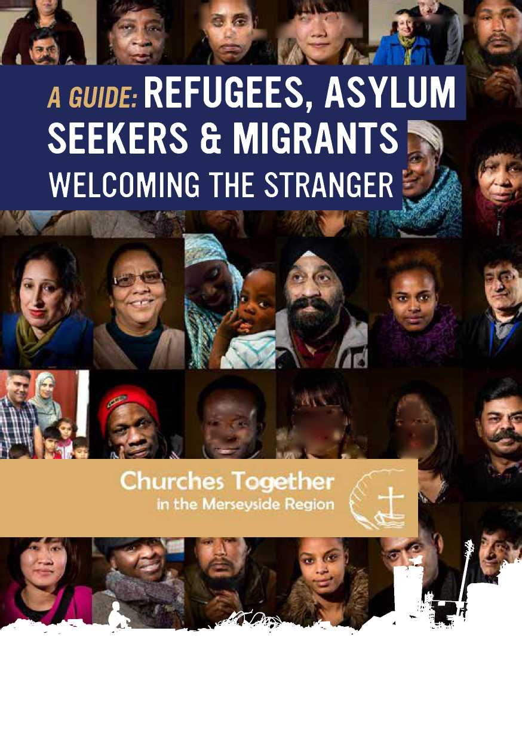

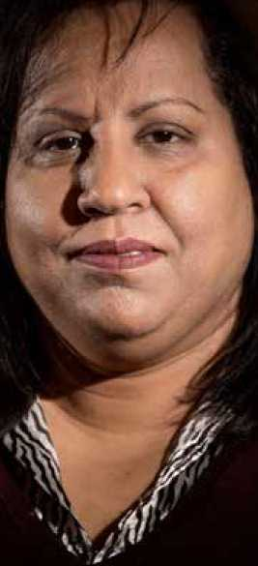

INTRODUCTION

“Indifference and silence lead to complicity whenever we stand by as people are dying of suffocation, starvation, violence and shipwreck... Biblical revelation urges us to welcome the stranger; it tells us that in so doing, we open our doors to God, and that in the faces of others we see the face of Christ himself.”

Pope Francis September 2015

This guide has been triggered by the international refugee crisis as it has unfolded through 2015 into 2016. It is inspired by the needs to respond to the Gospel, to the injunction to ‘welcome the stranger' and ‘care for our neighbour'. Most precisely it is a response to Pope Francis and his warning in September 2015, which is quoted above.

At Sunday's Angelus, on 6 September 2015, Pope Francis invited every parish, religious house and monastery in Europe to respond to the growing refugee crisis by offering a place of sanctuary to families fleeing from war and persecution in their home countries, a call echoed by Archbishop Justin Welby, who made accommodation available to Syrian refu­gees at Lambeth Palace.

On 3 September 2015 Archbishop Justin Welby said, “The Church has always been a place of sanctuary for those in need, and Churches in the UK and across Europe have been meeting the need they are presented with. I reaffirm our commitment to the principle of sanctuary for those who require our help and love. The people of these islands have a long and wonderful history of offering shelter and refuge, going back centuries - whether it be Huguenot Christians, Jewish refugees, Ugandan Asians, Vietnamese boat people or many, many more. It has always been controversial at the time it happened, always been seen as too difficult. Yet each time we have risen to the challenge and our country has been blessed by the result.”

As Christians we have come together to provide an initial practical response with this booklet. Its purpose is primarily to provide information to Church communities about the nature of the refugee crisis: its international and UK context, the legislative and bureaucrat­ic frameworks that are applied in the UK, and the challenge it presents to the Churches.

The nature of the information is set by the format of a booklet. The information is therefore essentially limited and basic in its depth, while seeking to be comprehensive in its scope. Pointers are given however to where people might find fuller information. The international, political, and legal landscapes are changing quickly so there will be a continuing need to seek out the most up-to-date information.

The purpose of the booklet is to inspire us to 'see, judge, and act', a process, in the Chris­tian tradition, of reading and responding to the signs of the times. We aim to provide the basic information which will allow the reader to inquire further, and judge the matter for themselves, so that we can respond and act as Christians to the plight of asylum seekers and refugees.

WHAT CAN WE DO?

There is much scope for action. We can do many things, such as:

* Helping new arrivals to integrate into local communities
* Donating money to groups and charities who help asylum seekers and refugees
* Donating clothes and goods to these organisations
* Volunteering to develop skills, like teaching English to asylum seekers and refugees
* Helping asylum seekers with transport costs, like buying saver tickets or travel passes
* Campaigning and adding our Christian voices to the local and national picture
* Praying and reflecting, and keeping the issue in the forefront of our minds
* Supporting the City of Sanctuary and Places of Welcome local and national movements

STATEMENTS FROM CHURCH LEADERS

“When Pope Francis reminded us of our duty to respond to the refugee situation he touched our hearts and our consciences. This booklet will help to remove some of the confusion surrounding this complex situation so that we will be better informed. We can then hope to make wise decisions about how to use our resources in the face of this continuing crisis.” Archbishop Malcolm McMahon Archdiocese of Liverpool

“The refugee crisis is one of the most urgent facing our region, our nation, our country and our world. As a church we are called and moved to respond to help those in need. We must work together, as together we are most effective. That is why I am happy to support this initiative by Churches Together in the Merseyside Region, to help the local churches to work together to welcome and help a stranger in need.”

Bishop Paul Bayes Diocese of Liverpool

“As human beings, we recognise that those who arrive seeking refuge in our country, need to be welcomed, supported and helped to integrate within our communities. As Christians, we can be a key catalyst in developing “communities of welcome” by both developing our buildings as places of welcome, but also working with others within our neighbourhoods to provide opportunities for integration and relationship building.”

Revd. Phil Jump

North Western Baptist Regional Minister

"Do not forget to entertain strangers, for by so doing some people have  
entertained angels without knowing it." Hebrews 13:2

"I tell you the truth, whatever you did for one of the least of these  
brothers of mine, you did for me." Matthew 25:40

CONTENTS

Chapter 1 ASYLUM SEEKERS, REFUGEES & MIGRANTS - Terms & Definitions

Chapter 2 ASYLUM SEEKERS & REFUGEES - Who, Why & Where

Chapter 3 ASYLUM SEEKERS & REFUGEES - Fact & Fiction

Chapter 4 ASYLUM SEEKERS & REFUGEES - The Procedures

Chapter 5 ASYLUM SEEKERS & REFUGEES - Benefits & Entitlements

Chapter 6 THE REFUSED ASYLUM SEEKER - What Happens Next?

Chapter 7 THE REFUGEE CRISIS - People's Stories

Chapter 8 THE REFUGEE CRISIS - What The Churches Say

Chapter 9 THE REFUGEE CRISIS - What We Can Do

Chapter 10 THE REFUGEE CRISIS - Prayers For Refugees

Published by: Churches Together Merseyside Region

Copies: c/o Archdiocesan Justice and Peace Commission, Liverpool, L17 1AA

Tel: 0151 522 1080 Email: [s.atherton@rcaol.co.uk](mailto:s.atherton@rcaol.co.uk)



:£

**,1**

■<

* 1

ASYLUM SEEKERS, REFUGEES & MIGRANTS - TERMS & DEFINITIONS

Three terms or labels are used in the current refugee crisis: ‘asylum seeker', ‘refugee', ‘migrant'. Sometimes they are used by the media interchangeably, one meaning the same as the other. They are quite different and this section tries to explain the distinct meaning of each.

ASYLUM SEEKER, REFUGEE, MIGRANT?

o WHAT IS ASYLUM?

Asylum is the protection granted by a country to someone who has left their own country to find safety. If a country gives such protection that person becomes a refugee. The UK has signed and is bound by the 1951 United Nations Refugee Convention. Article 33.1 of the UN Convention says that such protection means: “No Contracting State shall expel or return a refugee in any manner to the frontiers of ter­ritories where his life or freedom would be threatened on account of his race, religion, nationality, membership of a particular social group or political opinion.” **o WHO IS AN ASYLUM SEEKER?**

An asylum seeker is someone who has made application for protection in line with the UN 1951 Refugee Convention, and the 1967 European Convention on Human Rights. A person applies for asylum on the grounds of having a well-founded fear of persecution because of race, religion, nationality, political belief or membership of a particular social group. Once they have officially applied for asylum, the asylum seeker can claim support, until their application is dealt with, and their request is agreed or refused. If it is agreed they have refugee status. If the request is denied they become a ‘refused asylum seeker'.

o WHAT IS REFUGEE STATUS?

A person given refugee status is normally granted leave to remain in the UK for 5 years. At the end of that period they can apply for Indefinite Leave to Remain (ILR).

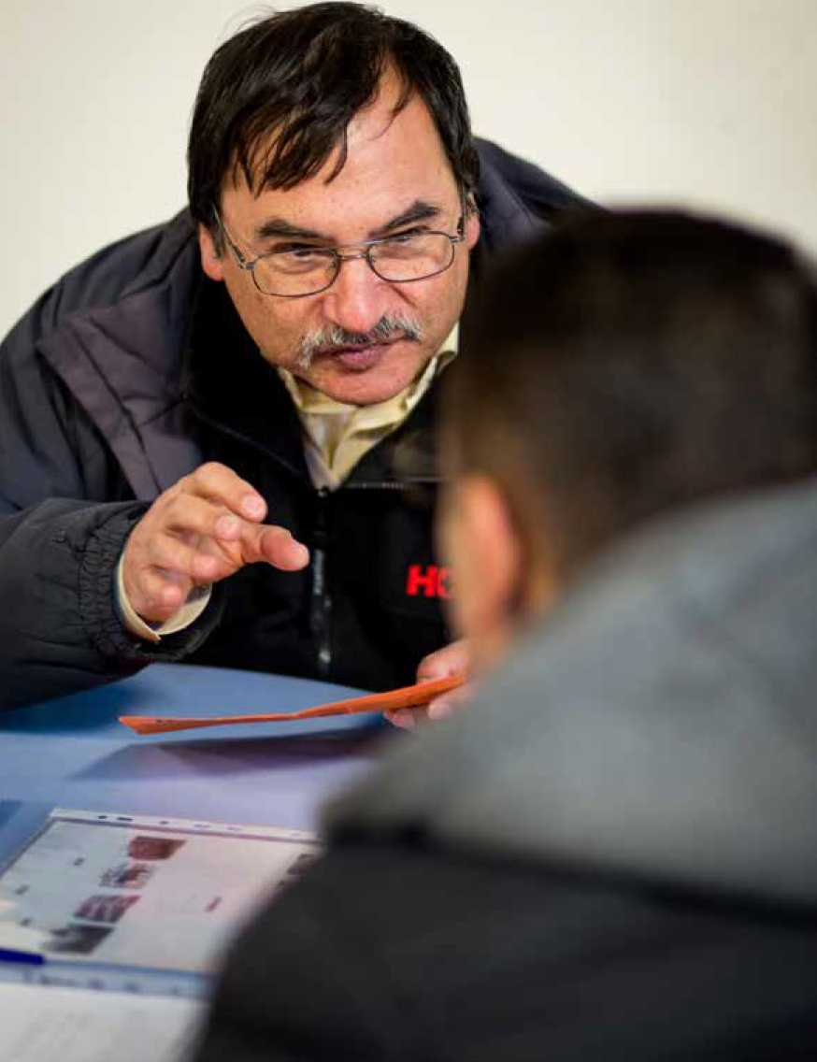

WHO IS A REFUSED OR FAILED ASYLUM SEEKER?

Once an asylum seeker has their request for asylum officially refused they no longer have any lawful right to remain in the United Kingdom. They no longer receive any entitlements, accommodation or benefits of any kind. Some refused asylum seekers voluntarily return home, others are forcibly sent home, but some go missing and stay illegally. Without any means of support, or accommodation, destitution often results.

WHAT IS INDEFINITE LEAVE TO REMAIN (ILR)?

Indefinite leave to remain (ILR) is a form of immigration status given by the Home Office. ILR is also called ‘permanent residence' or ‘settled status' as it gives permission to stay in the UK on a permanent basis. A refugee is allowed to work, and can apply for citizenship at the end of the five years.

o WHO IS A MIGRANT?

A migrant is a term that has no legal meaning but is used to describe someone travelling to another country and is usually used to mean an economic migrant, that is, someone who has left her/his own country and seeks to find employment in another country. They may or may not have a legal right to work. A citizen of the UK has the right to work in any country in the European Union, and any citizen from an EU country has the right to work in the UK. There are some important conditions but generally any citizen from an EU country has the right to live, work and study in any other EU country.

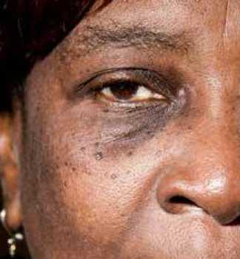

ASYLUM SEEKERS & REFUGEES - WHO, WHY & WHERE

This chapter seeks to explain briefly why large numbers of people are fleeing the Middle East, Africa, and Asia to come to Europe, and how and why some of these are seeking asylum in the UK. The numbers’may not be accurate because not everybody is counted as they arrive and move across borders, and not everyone seeks asylum. Most do, and the United Nations High Commissioner for Refugees (UNHCR) provide the following figures.



Italy

63,660

Austria

28,060

Netherlands

23,850

Switzerland

22,110

WHAT ARE PEOPLE FLEEING FROM?

The total number of refugees has increased significantly and consis­tently over the past four years.

2O1£_10.4m^«

2oi^j0.5m^B

1. 11.7m
2. 14.4m|
3. 15.1m

Within 4 years the global refugee popula­tion grew by 4.7 million persons - some 45 per cent.

The main contributing factor to this trend has been the war in the Syrian Arab Re­public. Excluding that country, the in­crease from the end of 2011 to mid-2015 would have been only half a million refu­gees (+5%). Clearly, the devastating ef­fect of the Syrian conflict is being felt far beyond its borders.

In addition to the Syrian crisis, the out­break of armed conflicts or deterioration of ongoing ones in Afghanistan, Burundi, the Democratic Republic of the Congo, Mali, Somalia, South Sudan, and Ukraine, among others, have contributed to pre­vailing trends.

WHERE DO ASYLUM

SEEKERS CLAIM

ASYLUM IN EUROPE?

For 2014 the claims for asylum in the top 20 European countries were as follows:



Germany Turkey Sweden

173,070 87,820 75,090

France Hungary UK

59,030 41,370 31,260

|  |  |
| --- | --- |
| Denmark | 14,820 |
| Belgium | 13,870 |
| Norway | 12,640 |
| Bulgaria | 10,790 |
| Greece | 9,450 |
| Poland | 6,810 |
| Spain | 5,900 |
| Finland | 3,520 |
| Montenegro | 2,310 |

WHERE ARE THOSE SEEKING ASYLUM IN THE UK COMING FROM?

From January to July 2015 the applications for asylum in the UK totalled 19,196. The top ten countries of origin for 12,768 of these were:



Eritrea

2,034

10%

Pakistan

1,700  
9%

Syria

1,314  
7%

Albania

996

5%

Sri Lanka

805

4%

|  |  |  |  |  |
| --- | --- | --- | --- | --- |
| Sudan | Iran | Afghanistan | Nigeria | Iraq |
| 1,736 | 1,353 | 1,224 | 862 | 744 |
| 9% | 7% | 6% | 4% | 4% |

Asylum seekers from other countries: 6,428 (35%)

WHY ARE THESE PEOPLE SEEKING ASYLUM?

There are civil wars, conflicts and suppression of human rights as identified by the UN in these countries.

At the start of 2016 the Syrian crisis is the most explosive element in the human tragedy, but there are ongoing situations that are forcing people to flee their lands.

Eritrea was described as ‘possibly having the world's worst human rights record' by the UNHCR in a report on 8 June 2015. It said individual citizens are “routinely arbitrarily arrested and detained, tortured, and disappeared or extrajudicially executed”.

There are no free and fair elections. It is a single party state, and the election of the president has not been held since independence in 1993. The press and the internet are very strictly controlled. All females and males between the age of 18 and 55 have to do military service, which is supposed to be for only 18 months but is often extended and unlimited. Very often people flee to escape this military service/imprisonment.

Sudan has been subject to civil war and famine since 1983, and it is estimated that over 2 million people have died as a result. Civilians face indiscriminate bombings and targeted attacks from both government and rebel forces. Humanitarian relief workers have been targeted in areas like Darfur.

There is no democracy or political freedom. There is no religious freedom. Muslims who convert to Christianity can face the death penalty for apostasy. According to a 2013 UNICEF report, 88% of women in Sudan had undergone female genital mutilation. In another UNICEF report, in 2008, it stated that there were as many as 6,000 child soldiers in Darfur.

The other countries listed often suffer from civil war and internal terrorism, with frequent bomb attacks in centres of population. Political liberties are few. Arbitrary arrest, punishment and torture, and imprisonment are frequent. Religious persecu­tion, and the persecution of women and ethnic minorities, are common. Political opposition is rarely tolerated, and minority political and ethnic groups are often targeted by the government.

WHAT HAS THE GOVERNMENT SAID IT WILL DO ABOUT THE SYRIAN REFUGEE CRISIS?

The Government said in September 2015 that it would take 20,000 refugees from the camps on the borders of Syria over the next five years (2016-20). It plans that the refugees would not immediately be granted full refugee status, giving them a right to settle, but instead they will be given a humanitarian status that will allow them to apply for refugee at the end of five years or return home. This is an extension of the Vulnerable Persons Relocation Scheme (VPRS) launched in 2014 to help Syrian refugees, subsequently called the Syrian Resettlement Programme (SRP).

The government intends to organise the resettlement of these refugees in collabo­ration with the UN High Commissioner for Refugees (UNHCR) to identify those that will be allowed to come to the UK. Full funding of this refugee programme will be given to local councils, with the monies coming from the government overseas aid programme. The rate at which the 20,000 refugees will come to the UK will depend on the UNHCR identifying the refugees and how quickly local councils will be able to process the applicants.

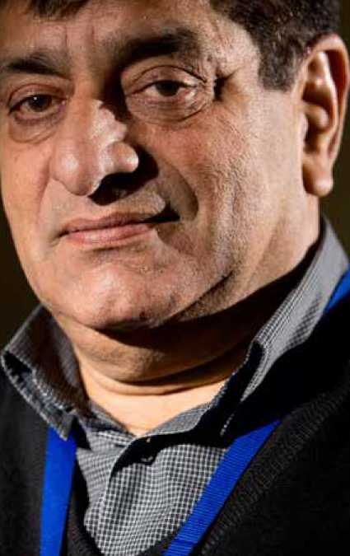

ASYLUM SEEKERS & REFUGEES -

FACT & FICTION

This guide seeks to help people separate truth from fiction, fact from myth, so we can understand and discuss the refugee problem reasonably and free from misinformation.

FACT OR MYTH?

True or untrue? Here are the real facts about asylum seekers.



MYTH

The UK has more  
asylum seekers  
than most countries?

**FACT** No it does not.

The UK receives just

**5%**

of all new asylum  
claims within the EU.

Germany had the largest number of asylum claims in 2014 with over 173,000 applications. The US was second with 121,200. The UK received 31,300 new applications for asylum in 2014. This was 5%, a twentieth, of all the claims in the European Union.



MYTH

Most asylum seekers  
are bogus  
asylum seekers?

**FACT**

There is no such thing as an ‘illegal' or ‘bogus' asylum seeker.

Under international law, anyone has the right to apply for asylum in any country that has signed the 1951 UN Refugee Convention and to remain there until the authorities have assessed their claim.

This Convention guarantees everybody the right to apply for asylum. It allows people to travel, by legal or unofficial or illegal means, to any country which has signed the Convention, to seek asylum.

FACT OR MYTH?



MYTH

Asylum seekers and  
refugees get large handouts  
from the state

**FACT**

Asylum seekers do not receive large handouts.

They actually receive around

a day

Asylum seekers get state support while their application is being dealt with. This is usually £36.95 per week - about £5 a day to live on.

Additionally, asylum seekers are not allowed to work, do not qualify for council housing and they cannot choose where they live while waiting for their application to be dealt with.



**MYTH**Britain's asylum  
system is soft.

**FACT**

Britain's asylum system is very tough.

Number of refused UK asylum claims in 2014 =

6 OUT OFlO

The UK asylum system is strictly controlled, and the procedures that asylum seekers have to follow are very complex, about where they have to go to make a claim, or where they have been sent to live while their claim is considered, for example.

It is very difficult to get asylum in the UK. In 2014, six out of ten applications were refused. These decisions are often appealed. Three out of four refused asylum seekers appeal, and one in four of these are successful. This means that overall, about half of applications are approved in a process that may take years.

Refugees make a huge contribution to the UK.

MYTH

Asylum seekers drain the  
welfare budget and NHS.

**FACT**

«£~4

• Immigrants, including refugees, pay more into the public purse compared to their

UK born counterparts. *(Institute for Public Policy Research, Paying their way: the fiscal contribution of immigrants in the UK, 2005).*

• An estimated 30,000 jobs have been created in Leicester by Ugandan Asian refugees since 1972. *(The Observer, They fled with nothing but built a new empire, 11 August 2002).*

• About 1,200 refugees are medically qualified doctors as recorded on the British

Medical Association's database *(BMA/Refugee Council refugee doctor database, 4 June 2008).*



**kJ**

MYTH

Most asylum seekers  
end up as criminals.

**FACT**

Asylum seekers and refugees are law abiding citizens.

The vast majority of people seeking asylum are law abiding people.

*(Association of Chief Police Officers [ACPO]: Guide to meeting the policing needs of asylum seekers and refugees, 2001).*

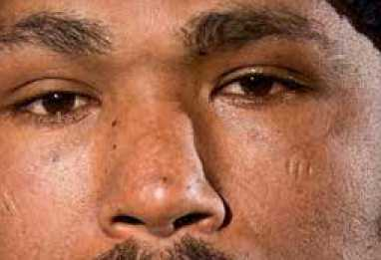

ASYLUM SEEKERS & REFUGEES - THE PROCEDURES

This chapter sets out the procedures and stages of seeking asylum. It can be a complicated process, and time scales are often not kept to by the authorities. It is important to note that the right to claim asylum is enshrined in international law. Governments are obliged to provide protection to people who meet the criteria for asylum. The UK has signed these international laws and they are part of UK legislation. Although some asylum seekers might enter the UK illegally, once they have applied for asylum they are no longer ‘illegal'. Anyone seeking protection is entitled to stay in the UK while awaiting a decision on their asylum claim.

THE PROCEDURES

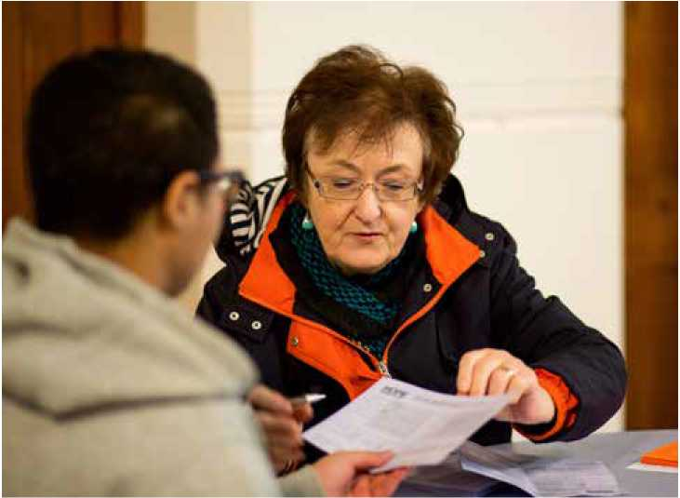

CLAIMING ASYLUM ON ARRIVAL

Asylum claims should be made to an im­migration officer as soon as an asylum seeker arrives in the UK. Once a person has passed through immigration control and is inside the UK, they must claim asy­lum at the Asylum Screening Unit of UK Visas and Immigration (UKVI), which re­placed the UK Border Agency, in Croydon (in south London). No support, financial or otherwise, is provided by the authorities to asylum seekers to travel to Croydon from whatever part of the UK they arrived in.

INITIAL SCREENING INTERVIEW

Asylum applicants then have to attend a screening interview with a case worker, to provide personal details such as iden­tity, country of origin, when and how the person arrived in the UK, and what doc­uments they have, such as a passport or other identity papers. The asylum seek­er is fingerprinted and a photo is taken which is put on the Application Registra­tion Card (ARC) which is issued to them.

THE ASYLUM SEEKING PROCESS

41

Applicant removed Home Office decides

from the UK fl on the claim

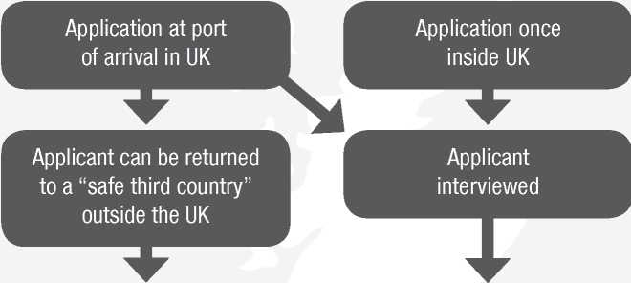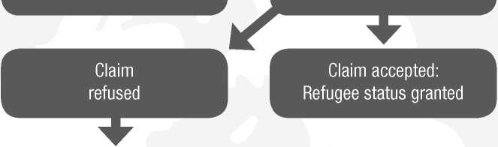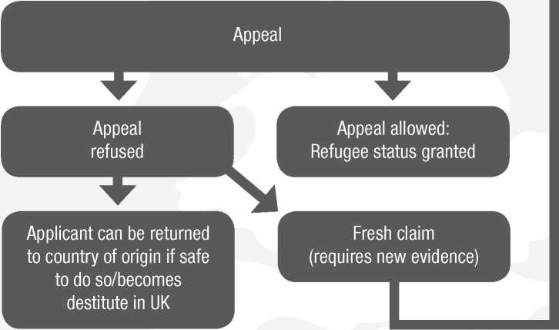

THE ASYLUM INTERVIEW

The ‘asylum interview', is held within the next couple of weeks. This is when the applicant tells their story to the case worker, and what it is they fear in their own country. The story and any sup­porting documents and details are then checked. Asylum seekers are then dis­persed to one of the 15 Reporting Cen­tres across the UK. They are expected to produce their ARC when they report. **WHAT IS DETENTION, AND HOW MANY ASYLUM SEEKERS ARE DETAINED?**

In the UK, thousands of asylum seekers are held in immigration detention centres each year. Under the Detained Fast Track (DFT), some asylum seekers are immedi­ately detained on arrival for the duration of their application and appeal, in places like Harmondsworth Immigration Remov­al Centre or Yarl's Wood Immigration Re­moval Centre.

The Court of Appeal has recently decided that no one should be detained for more than five months. The Home Office is ap­pealing against this.

In 2012, of 21,843 main applicants for asylum, 11.4% (2,482) applicants were detained under DFT. In 2013, 203 children were detained in immigration re­moval centres, with 155 being under the age of 11.

As a principle, the United Nations High Commissioner for Refugees (UNHCR) opposes the detention of people seeking asylum.

**MAKING THE DECISION** According to the 1951 UN Refugees Con­vention a person who has reason to fear persecution in their country because of their race, religion, nationality, member­ship of a particular social group, or po­litical opinion, should be recognised as a refugee.

Decisions often depend on whether the case workers dealing with the application find the person's account to be believable, consistent and accurate, and that they had followed the procedures properly.

Applicants who are granted refugee sta­tus by UKVI are given leave to remain in the UK for 5 years. They are free to work, and are eligible for mainstream benefits. If they have a spouse and children outside the UK they can apply to join the refugee in the UK. After 5 years they can apply for indefinite leave to remain, which will nor­mally be granted, the exceptions are usu­ally people who have had serious criminal convictions.

I

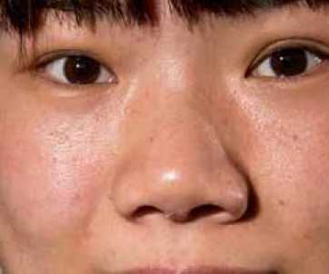

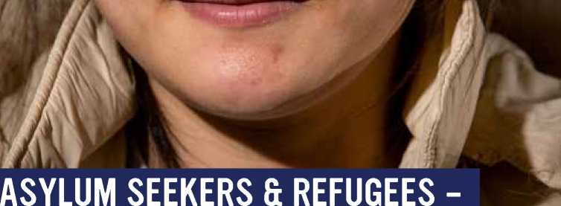

BENEFITS AND ENTITLEMENTS

This chapter explains what benefits and entitlements asylum seekers get, and also what happens regarding those benefits when refugee status is granted. Asylum seekers are ‘persons subject to immigration control' in the benefit rules. They instead have to rely on Home Office support which is provided at a level less than the minimum the law allows anyone else to live on.

WHAT BENEFITS DOES AN ASYLUM SEEKER QUALIFY FOR?

Upon arrival an asylum seeker qualifies for:

* A bed (if single) or room (if a family) in an 'Initial Assessment Hostel'
* £90 to provide for their needs until interviewed, which should be within 18 days but often takes longer

When an asylum seeker's claim is registered they are entitled to the following benefits:

* Money support

Financial support is provided in cash, collected weekly from Post Offices using the ‘Application Registration Card' (‘ARC card') which is issued to asylum seekers early in the asylum process as confir­mation of their identity and immigration conditions. The Post Office can be some distance from their accommodation so the cash might be eaten up by transport costs, or the asylum seekers are left to walk long distances.

This weekly payment amounts to £36.95. This means that a couple with no children will receive £73.90, as will a lone parent with one child. A single parent with two children will get £110.85, a couple with one child will get £110.85, and a couple with two children will get £147.80.

* Accommodation support

Asylum seekers can apply for accom­modation. If UKVI accepts an application the asylum seeker will be offered accom­modation outside London and the South East, and will have no choice about where that is. The asylum seeker is allowed to remain there until their claim, and their appeal if they have been refused, is de­cided.

(UKVI has contracts with three private companies, G4S, Serco and Clearel to provide housing in different parts of the country. The National Audit Office stated that G4S and Serco were failing to meet some of their key performance targets, notably relating to the standards of prop­erty and the time taken to acquire prop­erties for asylum seekers. The accommo­dation allocated to asylum seekers is not paid for by the local council. It is nearly always ‘hard to let' properties, where oth­er people do not want to live).

* Health support
* Maternity payment - a one-off £300 maternity payment if your baby is due in 8 weeks or less, or if your baby is under 6 weeks old.
* Basic health care
* Free prescriptions for medicine
* Free dental care
* Free eyesight tests and help paying for glasses

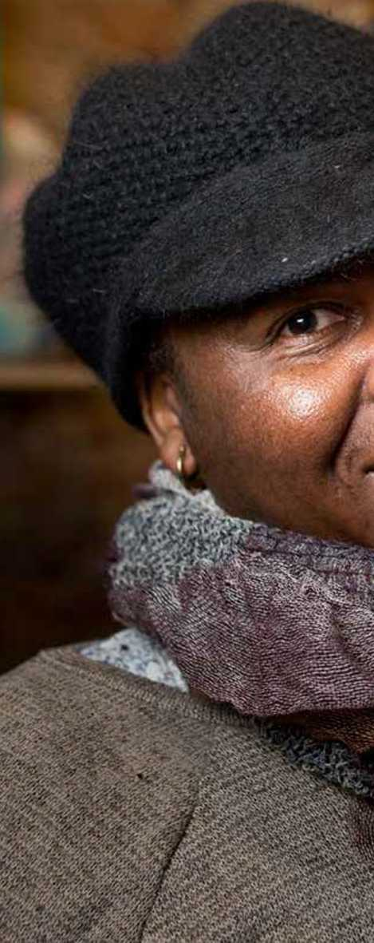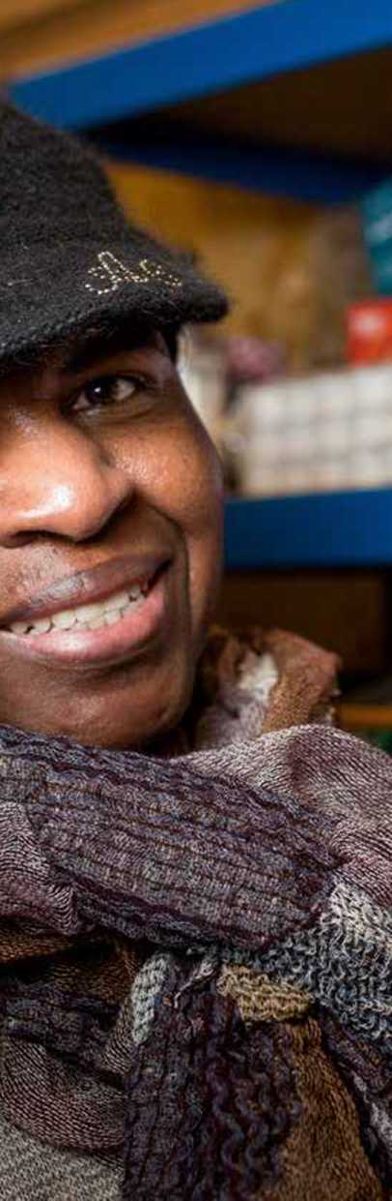

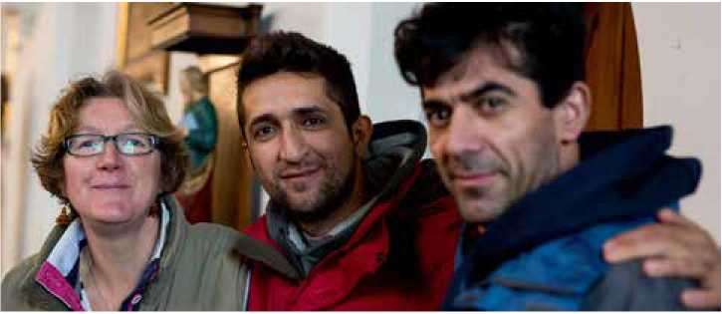

* Education support

Children must attend school if they are aged 5 to 17, and children may be able to get free school meals.

WHAT BENEFITS DOES AN ASYLUM SEEKER NOT QUALIFY FOR?

* They are not allowed to work

(unless their application is still undetermined after a year, in which case they can apply for permission to work, but this applies to very few people)

* They are not allowed to hold a driving licence
* They are not allowed to receive training
* They are not allowed to study in higher education

An asylum seeker will not qualify for the payment card if they don't take the

offer of somewhere to live

• Asylum seekers are not allowed to claim mainstream benefits

WHAT BENEFITS DOES A REFUGEE QUALIFY FOR?

Children must attend school if they are aged 5 to 17, and children may be able to get free school meals. Asylum seek­ers whose claims are granted, and who therefore become refugees, find their support from the Home Office stops and the person is given 28 days to navigate the social security system and also, in many cases, vacate their accommodation and find somewhere else to live. The per­son is allowed to claim benefits and tax credits on the same basis as a UK nation­al as they are no longer a ‘person subject to immigration control'.

Source: <http://www.cpag.org.uk/con> tent/refugees-and-benefits

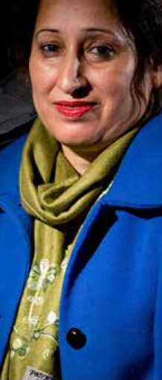

THE REFUSED ASYLUM SEEKER - WHAT HAPPENS NEXT?

This chapter explains what happens when a claim for asylum is refused. Most asylum seekers have their claim for asylum turned down or refused.

WHAT IS A REFUSED ASYLUM SEEKER?

A refused asylum seeker is someone whose claim for asylum has been turned down, or refused. They have been unable to prove that they would face persecution back home, and they have been told to leave the country. If a person does not leave the UK after their claim has been refused, UK Visas and Immigration (UKVI) may arrange an enforced return to their country of origin.

However some refused asylum seekers cannot be returned to their country of origin if that country is subject to a level 2 or 3 humanitarian crisis as defined by UNCHR e.g. Syria, Yemen, Somalia, and Eritrea. Some countries refuse to accept returning asylum claimants e.g. Iran, and Saudi Arabia.

WHAT APPEAL CAN A REFUSED ASYLUM SEEKER MAKE?

Most asylum seekers have a right of appeal if their claim is refused. Anyone wishing to make a 'fresh claim' or a 'sec­ond claim' must travel to Liverpool, to the offices of the UKVI Further Submis­sions Unit, and at their own expense.

The grounds for the appeal can be such as new evidence, changed circum­stances in the country of origin, or legal procedures not being followed. Refused asylum seekers are allowed to remain in the UK while they wait for their appeal.

An independent Immigration Judge, who is not employed by the Home Office, hears the appeal. If the appeal is rejected it is only possible to make a further appeal on a point of law.

About 25%-30% of appeals against re­fused claims are upheld.

WHAT BENEFITS ARE REFUSED ASYLUM SEEKERS ENTITLED TO?

Asylum seekers do not continue to re­ceive the normal asylum seeker's support after their application has been refused.

Asylum seekers whose applications have been refused are able to apply for, but may not receive, a basic support pack­age known as “hard case” or “Section 4” support. There is no cash support. The support consists of accommodation, on a no choice basis, and board in the form of an ‘Azure card', pre-loaded with £35.39 a week for a single asylum seeker. It can only be used in specific supermarkets and shops. The Azure card does not cover any travel costs, so no financial support is pro­vided for even local travel costs. In order to receive this support the applicant must agree to return to their country of origin. If a person does not leave the UK after their

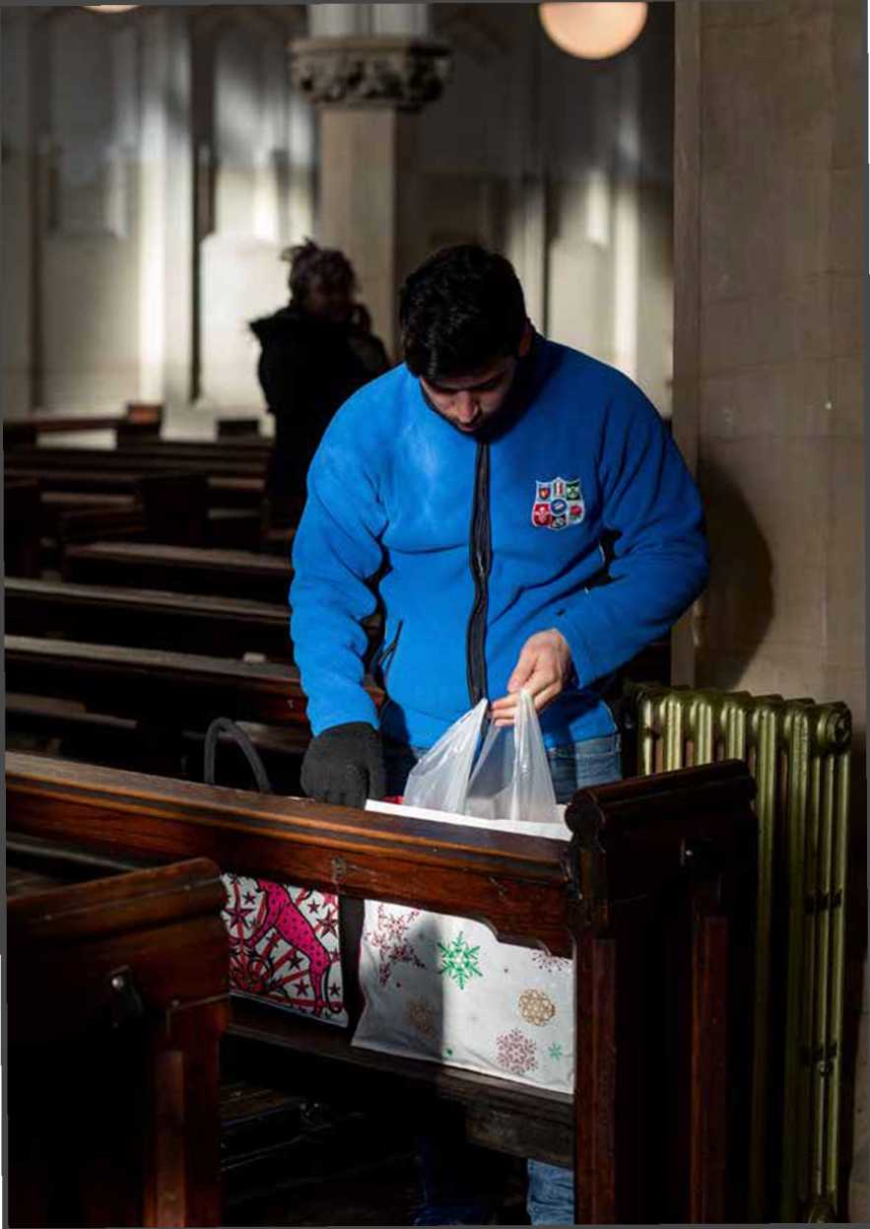

claim and any appeal have been refused, the UK Visas and Immigration may arrange an enforced return to their country of origin.

WHAT DOES THE BRITISH RED CROSS SAY ABOUT THE WORKINGS OF THE AZURE CARD?

In a 2014 report, ‘The Azure payment card: the humani­tarian cost of a cashless sys­tem', its key findings were:

* The Azure card often fails to work be­

cause of technical difficulties - leaving people without financial support for days.

* Only certain shops and supermarkets accept the card - and even these sometimes refuse to accept it or mis­understand how it works.
* There are restrictions on what can be bought with the card. For example, it does not cover school trips or travel fares.
* Getting to essential appointments, such as medical and legal ones, can be a huge problem.
* Some people have to walk long dis­tances to get to a supermarket that ac­cepts the card (which may not be the nearest or cheapest).
* Nearly three-quarters of organisations in our survey believe that Azure card users struggle to provide enough food for their children and other dependents.
* It is difficult for families on the Azure card to stay healthy - which can in­crease the costs for other services.
* Living on the Azure card creates un­necessary suffering for people who have fled war, violence and persecu­tion - and are already in desperate situations.
* The payment system can affect their mental health, ability to maintain re­lationships, and participation in social, cultural and religious life.
* The card can cause stigma as it singles its users out at the checkout.
* Some cashier assistants aren't prop­erly trained, which can cause embar­rassment.

ASYLUM SEEKERS AND DESTITUTION

Those asylum seekers who have failed to be granted refugee status can fall into destitution. No financial support or bene­fits are available to asylum seekers who have failed in their claim unless they make an appeal. If an appeal or second claim is made, and this is refused, then all benefits stop. As a result destitution may follow.

|  |  |  |
| --- | --- | --- |
| **i S** | — | **V j** |
| **B I**  **Wk \** |  | **mV** |

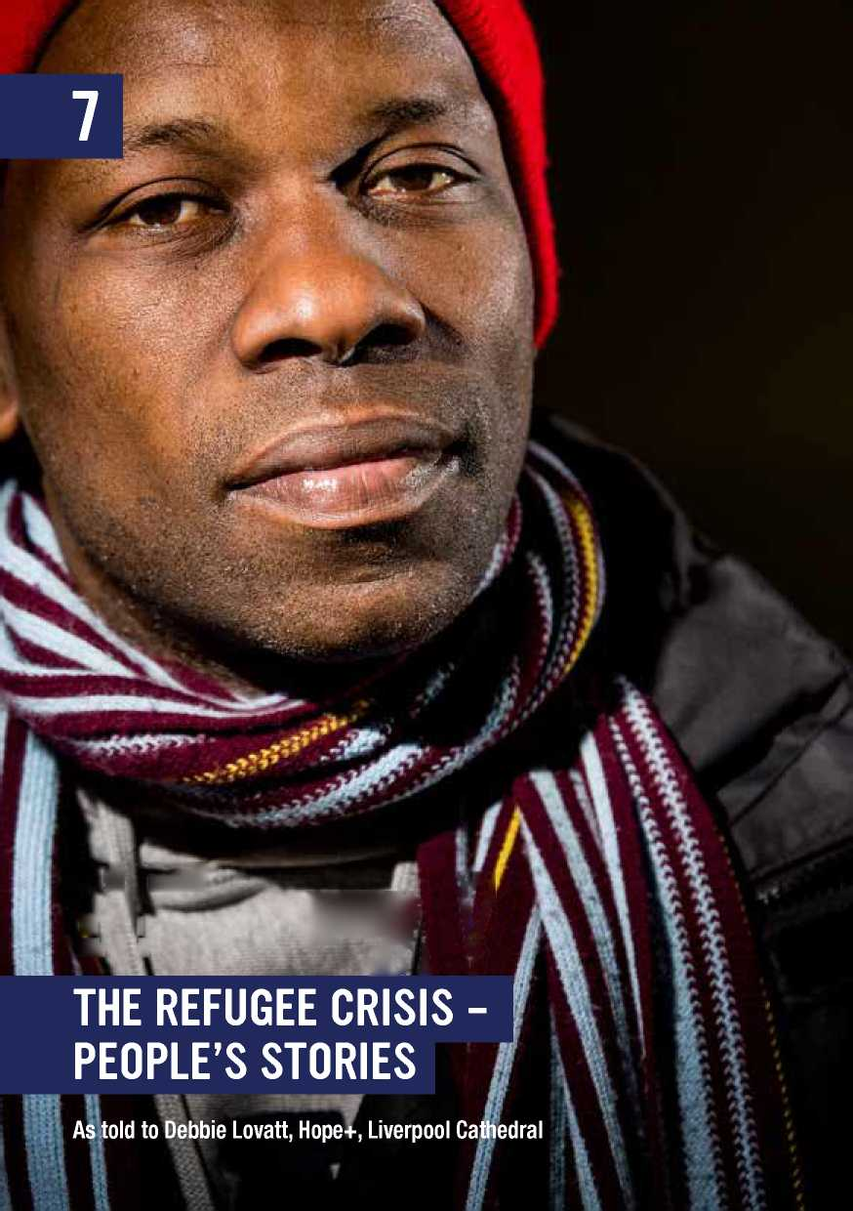

MO, RA AND WA (FROM SYRIA)

In better times, trips through the countries these men passed through as they fled war in Syria could inspire glossy hardback accounts of histories, customs, cuisine and culture with colour-drenched photos to captivate and make the reader envious. Not that luxury for our trio. Each comes from a different part of Syria: Dera'a and Quneitra in the south west and Aleppo in the north. They list each country they transited: From Syria to Lebanon, to Turkey by plane, to Greece by sea, and on foot through Macedonia, Serbia, (one took a plane from Greece to Spain before flying to Hungary) Hungary, Austria, Germany and France. To England. One in a truck to Dover, two on a train. All seeking a place of refuge with respect for people. Away from war, conflict, competing militias, forced conscription, destruction. One, a labourer, calls it a “Wonderful Kingdom”. He's single and wants to be able to get on with life in peace, make an honest living and be away from fear. Another is Kurdish and fled, leaving behind his wife and children. They're safe for now. It's the men the militias want. Fighters. The other speaks of the terror of the conflict and how frightening the journey was, especially the sea crossing. He has a degree in English, that's why he pushed himself to reach England. He wants to lead a simple life with a steady job away from war. They pull out phones and show photos of the journey. They're in colour. Recent. **T (FROM ERITREA)**

T's journey to England took 14 months. Most of it was on foot. It was a frightening journey for this former soldier who had served for 12 years. He had to cross countries wracked by problems, intolerances and hostilities of their own. At home in Eritrea his faith was endangering him. He's a Pentecostal Christian, and that's not a minority faith the Eritrean government tolerates. He states: “There's no freedom in Eritrea.” T feared for his life after falling foul of the authorities and fled. He has a wife and their children are young, just 4 and 2. He hopes that his asylum claim will be successful and that he'll be able to bring them over to join him. The first place he fled to was next door Ethiopia, from there to Sudan and north to Libya. “It was very difficult, especially in Libya.” T spoke of bandits along the way, of rivalries between groups of smugglers, and having to depend on these people for his life. They were passed from one group to another and didn't even know where they were. “Were you frightened?” Emphatically: “Yes. Yes.” T crossed by sea to Italy: “It was better to risk the sea than to stay in Libya.” When he arrived in England a few months ago via France, T was suffering some health issues. He says he's better now. He hopes to be able to bring his family over and that they'll all be able to live in peace in England.

MM (FROM SYRIA)

MM left a town near the northern Syrian city of Aleppo together with a friend. Their families had raised some cash in order to get them out. Aleppo is close to the Turkish border so they were able to cross relatively easily. They made it to England via France and a litany of other countries. After a few attempts to jump onto a train at Calais, they managed it. The entire journey took them just two months. He is hesitant to talk, reluctant to revisit the last two months: His focus is on “now” and “next”.

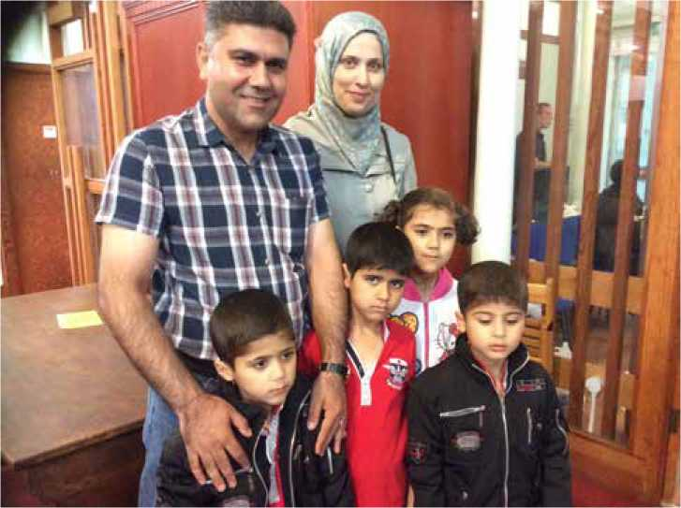

I explain the procedure at the food bank and he relaxes. Information is calming. Procedure is reassuring. “Oh yes, of course we were afraid on our journey.” I ask if they took the sea route. “I was more afraid in those hours on the boat than in the rest of my life put together. Many people died.” He pulls out his phone. I know it will contain upsetting photos so gesture for him to put it away. We both look down. “Lord, have mercy.” MM's home town is caught between an ISIS stronghold and the Syrian army. He worked as a Red Crescent volunteer until his neutrality was threatened by each side's need for more manpower. “I came to England because this country is famous for its humanity. I need to improve my English - I studied Arabic at Al Azhar University in Egypt. I just want to get married and live a peaceful life.”

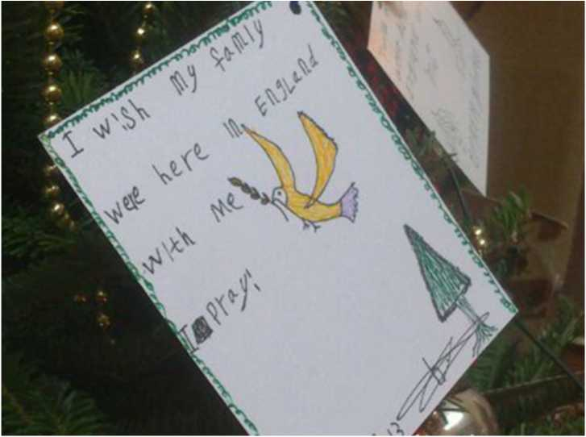

L AND HER 4 CHILDREN (FROM PAKISTAN)

L's family took a summer vacation trip home this July. They left Dubai for Islamabad. L's husband worked for the Pakistani Embassy in Dubai and was a member of the Intelligence Bureau. One day after arriving in Islamabad he was murdered by unknown assailants. L immediately returned to Dubai with their children and from there flew to England and claimed asylum. The children still don't know the full story of their dad's disappearance and L worries about the impact on them when they discover what happened. Aged 15, 13, 10 and 9, she feels the need to keep the full truth from them and to ensure their safety in this country. She states that they are all under threat in Pakistan making it unsafe for them to remain there; and they can't continue to live in Dubai as residency there depended on her husband's job. She has family in the UK already, but says she gets no support from them. They are fearful and worry that associating with her will bring her husband's killers close to them as well, either here or when they visit other family members in Pakistan. L speaks nervously and in a whisper while the children are out of earshot. She is focused on them and on their needs. “As long as my children are safe,” she says, repeating: “We're not safe in Pakistan because of my husband's work and his killers. I want peace and safety. That's why I want to live here in England.”

THE REFUGEE CRISIS -

WHAT THE CHURCHES SAY

This chapter identifies some of the key statements made by Church leaders, and points readers to sources for further comment and analysis by the Churches.

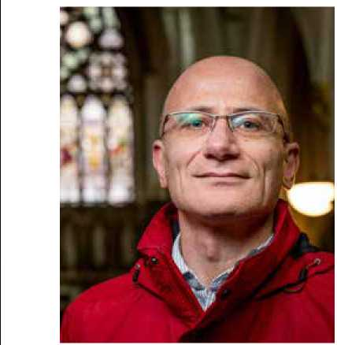

CHURCHES TOGETHER IN BRITAIN & IRELAND

Churches and Church leaders across Britain and Ireland are responding to the refugee crisis calling on their governments to take action, and providing support where possible.

The many and varied responses and initiatives can be found at: [https://ctbi.org.uk/how-the-churches- are-responding-to-the-refugee-crisis/](https://ctbi.org.uk/how-the-churches-are-responding-to-the-refugee-crisis/) **ROMAN CATHOLIC CHURCH**

Pope Francis - Message for the World Day of Migrants and Refugees, 17-18 January 2016

The mission of the Church, herself a pil­grim in the world and the Mother of all, is thus to love Jesus Christ, to adore and love him, particularly in the poorest and most abandoned; among these are cer­tainly migrants and refugees, who are trying to escape difficult living conditions and dangers of every kind. For this rea­son, the theme for this year's World Day of Migrants and Refugees is: Church without frontiers, mother to all.

The Catholic Church in England and Wales - Statement on the Refugee Crisis:

*‘Whatever you did for one of these least brothers of mine, you did for me (Mt 25:40)'*

The refugee crisis is a huge challenge, not only in Europe and the Middle East, but in many others parts of the world where large numbers of refugees live deeply un­certain and perilous lives. Consequently, as a Catholic community, and as a coun­try, we need to be committed to helping refugees over a long period. To sustain that effort we need moral imagination. We recognise that we can all contribute and play a part in helping to support the most vulnerable of refugees.

There is a dedicated website at: <http://www.catholicnews.org.uk/> Home/Featured/Refugee-Crisis-Open- Your-Hearts

Church without frontiers, mother to all.



**CHURCH OF ENGLAND** The Archbishop of Canterbury, the Most Revd Justin Welby, in his New Year Message on 1 January 2016, said:

“Jesus was a refugee - fleeing as a baby with his parents, returning years later to a strange new ‘home'. He tells us to be those who welcome the alien and strang­er, the poor and weak. As a nation we have always done so. In today's world hospi­tality and love are our most formidable weapons against hatred and extremism.”

In a statement on the refugee crisis facing Europe and the Middle East, the Archbishop said on 3 September 2015:

“My heart is broken by the images and stories of men, women and children who have risked their lives to escape conflict, violence and persecution. There are no easy answers and my prayers are with those who find themselves fleeing perse­cution, as well as those who are strug­gling under immense pressure to devel­op an effective and equitable response. As Christians we believe we are called to break down barriers, to welcome the stranger and love them as ourselves (Leviticus 19:34), and to seek the peace and justice of our God, in our world, today. The Church has always been a place of sanctuary for those in need, and Churches in the UK and across Europe have been meeting the need they are presented with. I reaffirm our commitment to the principle of sanctuary for those who require our help and love.”

Bishop of Leeds, Rt Revd Nick Baines:

“Perhaps the compassionate and costly response of Germany has something to do with a living memory of such humanitari­an need on their own land and caused by their own choices. There is no reason why we on our island should not demonstrate a similar compassionate imagination.”

See also <http://www.anglicannews.org> **THE WORLD COUNCIL OF CHURCHES**

The World Council of Churches (WCC), the Evangelical Lutheran Church in Ba­varia and the Evangelical Church in Ger­many jointly hosted a Church Leaders' Consultation on the European Refugee Crisis on 29 October 2015. 35 partic­ipants from places that are countries of origin of refugees, from those countries of transit and from host countries met. There was strong affirmation for the belief that “While we deeply deplore the crises forcing people to leave their homes, we welcome all refugees in Europe as we see in them the image of God, and as God's children they bring their gifts to our con­tinent... In the face of this challenge the Church promotes collaboration, coopera­tion and solidarity... We resist the tendency to look at the refugee crisis only in terms of numbers and statistics. This violates the Christian value of respect for the dignity of every human being. These are people with lives, families, homes, and youth”.

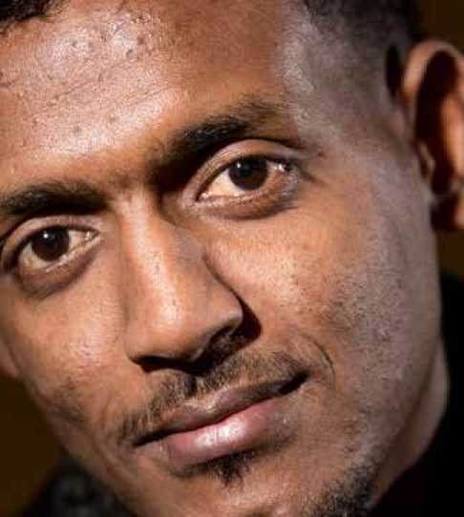

THE REFUGEE CRISIS -

WHAT WE CAN DO

This chapter suggests some actions we can take, and lists some of the contact details for organisations currently working with asylum seekers and refugees.

HOW TO HELP - ACTIONS

* Helping new arrivals to integrate into local communities
* Donating money to groups and charities, like those listed in this guide, who are active in helping asylum seekers and refugees
* Donating clothes and goods to these organisations
* Volunteering to develop skills, like teaching English to asylum seekers and refugees
* Helping asylum seekers with transport costs, like buying saver tickets or travel passes
* Campaigning and adding our Christian voices to the local and national picture
* Praying and reflecting, and keeping the issue in the forefront of our minds

Supporting the City of Sanctuary and Places of Welcome local and national movements

HOW TO HELP - DEVELOPING A STRATEGY

An example from Citizens UK:

Citizens UK is a coalition of people of goodwill, many of whom are members or representatives of the faith communities, who are keen to explore how local citizens can be inspired and empowered to provide practical support and welcome for those who arrive on our shores seeking refuge.

Citizens UK is developing a network of lo­cal resettlement councils to help create this atmosphere of welcome, and also to campaign for safe and legal routes of entry for refugees. A local welcome plan is based on four core principles:

* That the best people to offer a positive, long-lasting sustainable welcome to refugees who arrive in a community are the local civil society and commu­nity organisations and the residents of that area. Welcome and integration will be best served when local citizens are involved in the process of resettlement
* That local citizens, effectively organ­ised can focus on voluntary contribu­tions of welcome that complement the activities of the local statutory agencies and any of their contracted partners. Such activities can help to integrate the work of local councils, any contracted providers, and the existing community
* That the emphasis should be on what civil society does well, and the impor­tance of relationships and neighbour­liness rather than bureaucratic pro­grammes
* That plans should be made for the long term, in recognition that many of the most useful activities may take place well beyond the initial reception and orientation period

Practical steps to take in devel­oping a community of welcome:

Don't go it alone: Use the resources and contacts in this guide to find out who else is working in your area and how you can work together for mutual support and benefit.

Build a local team: Find out who else in your neighbourhood or community is concerned and moved by what is hap­pening. Try to bring together a diverse range of skills, insights and resources so that you can offer as full a response as you can. Faith communities are not the only people who are concerned to be involved, but we can often be a key catalyst in bringing those people together.

Bring people together: It sounds ob­vious, but get people together for a meeting. Create the opportunity to lis­ten, to share and to explore ideas. Citizens UK and other agencies offer ideas for structuring an initial meeting.

Identify your learning and training needs: You may not have all the skills and knowledge that you need to de­velop an effective response, but again there are many agencies and organi­sations who can offer information and training. Identify what your learning needs are, and use the contacts and net­works in this guide to help set this up.

Take action: It is important to raise awareness both of the plight of refu­gees and of your willingness to help. Think about what actions you could take locally (for example holding a vigil for those who have died in sea crossings; campaigning for safe and legal routes of entry; sharing statistics and informa­tion about the plight of refugees; asking your local council to commit to welcome a realistic number of refugee families). What can you do to make other local cit­izens aware of the need and the oppor­tunities to respond? What can you do to encourage politicians and other people of influence to develop a local response?

Celebrate the work you are doing: If the energy and enthusiasm of the group is to be sustained, it is important to take time to celebrate the work that it being done and the impact your work is making. Sustainable community ac­tion needs to be rewarding and enrich­ing for those who undertake it, as well as those for whose benefit it is planned.

Plan for refugees to arrive: We may not be clear when and how refugees will ar­rive in our neighbourhood, but we can be ready to welcome them. If you wait until refugee families arrive before making your plans, they may well be a little belated!

*This outline is based on various resourc­es produced by Citizens UK. If you would like to know more about the National Resettlement Council it has established, contact Citizens UK at <http://www.citizensuk.org>*

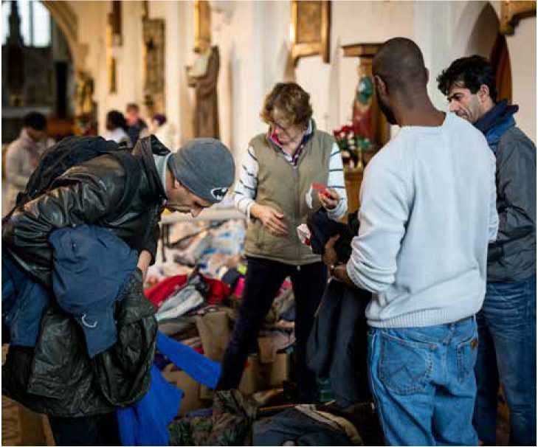HOW TO HELP - VOLUNTEERING & SAFEGUARDING

Volunteering and how volunteers are recruited and managed needs careful consideration, especially in relation to the support of refugees, particularly hosting refugees and asy­lum seekers in people's homes. It is also important to ensure people have some awareness of the UK Asylum sys­tem and that whatever support is offered does not contravene this or put either hosts or refugees in an illegal situation. One useful source of advice and guidance is Refugees and Asylum Seekers: A Briefing Note from the National Safeguarding Team-Sep- tember 2015. This can be found at: <https://www.churchofengland>. org/our-views/home-and-commun ity-affairs/asylum-and-immigration/ refugees-advice-on-support.aspx

*A comprehensive list of local action contacts and other local and national organisations offering assistance and help to refugees and asylum seekers can be found at the back of this guide.*

10

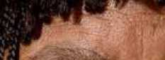

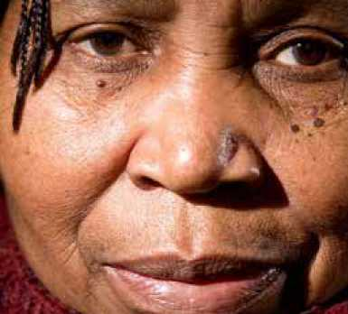

**PRAYERS FOR PEACE, REFUGEES & ASYLUM SEEKERS**

2

A prayer for peace by Pope St John Paul II that can be used to pray for an end to the war in Syria and for peace for the Syrian refugees fleeing violence.

Hear my voice, for it is the voice of the victims of all wars and violence among individuals and nations.

Hear my voice, for it is the voice of all children who suffer and will suffer when people put their faith in weapons and war.

Hear my voice when I beg You to install into the hearts of all human beings the wisdom of peace, the strength of justice, and the joy of fellowship.

Hear my voice, for I speak for the multitudes in every country and in every period of history who do not want war and are ready to walk the road of peace.

Hear my voice and grant insight and strength so that we may always respond to hatred with love, to injustice with total dedication to justice, to need with the sharing of self, to war with peace.

O God, hear my voice and grant unto the world Your everlasting peace. Amen.

A prayer for all refugees by Archbishop Justin Welby.

***A Prayer for Refugees***

ALMIGHTY and merciful God, whose Son became a refugee and had no place to call his own;

look with mercy on those who today are fleeing from danger, homeless and hungry.

Bless those who work to bring them relief; inspire generosity and compassion in all our hearts; and guide the nations of the world towards that day when all will rejoice in your Kingdom of justice and of peace;

through Jesus Christ our Lord. Amen.

A prayer from the Anglican Bishop of Manchester, the Rt Revd David Walker SSF.

Heavenly Father,

You are the source of all goodness, generosity and love.

We thank you for opening the hearts of many

To those who are fleeing for their lives.

Help us now to open our arms in welcome,

And reach out our hands in support.

That the desperate may find new hope,

And lives torn apart be restored.

We ask this in the name of Jesus Christ Your Son, Our Lord,

Who fled persecution at His birth

And at His last triumphed over death.

Amen.

A prayer from the Rev Phil Jump, Regional Minister for the North Western Baptist Association and JPIT Team Member from the Baptist Union of Great Britain.

God of all humanity

When your people were enslaved and displaced,

You led them to a land that they could call home;

When your people were in exile;

Your promise was that one day,

They would live in streets of play and laughter.

When your disciples were afraid and uncertain,

You spoke of a Fathers House

With mansions and places prepared.

We pray today for all those who have no place to call home,

Hearing the heart-cry of your word

For those who are without refuge.

Where shelter is ours to offer

Grant us the will and resolve to reflect the generosity of our Creator.

Where others stand in the way of those who need safe haven

May our cry for justice never falter.

May the idols of self-interest and economic gain

Never deflect us from the ways of your Kingdom.

Through Christ our Lord. Amen.

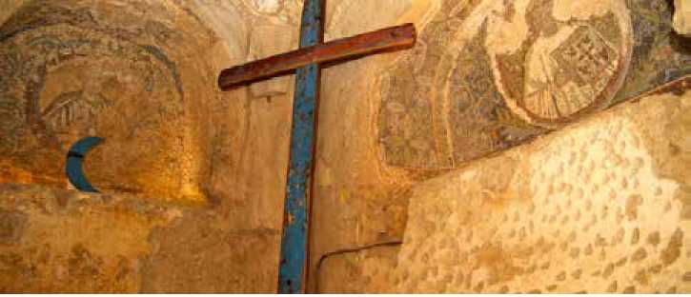

A prayer written by Revd Ruth Gee, former President of the Methodist Conference.

Aylan Kurdi, aged 3, from Kobani was washed up on a Turkish beach near Bodrum in September 2015. He was just one of thousands fleeing for safety from Syria and other parts of the world. The local fisherman who discovered his body among others on the beach said, “I came to the sea and I was scared. My heart is broken.”

***Lament for Aylan***

So small, so still

So beautiful in life

So unbearable in death

Carried by the sea

Carried by our tears

Carried gently in strong arms.

O God

Open the eyes of those with power

To see your children in their desperate need;

Open the arms of those in government

To welcome those who come to our shores;

Open the hearts of each one of us -

Move us to sorrow, anger and action

That the salt sea of sorrow

May be turned to soothing waters

And that tears of desperation

May become tears of joy.

O God, help your people.

A final challenge.

I was hungry

and you formed a working group and discussed my hunger.

I was imprisoned

and you crept off quietly to your chapel

and prayed for my release.

I was naked

and in your mind you debated the morality of my appearance.

I was sick

and you knelt and thanked God for your health.

I was homeless

and you preached to me of the spiritual shelter of the love of God.

I was lonely and you left me alone to pray for me.

You seem so holy, so close to God.

But I'm still very hungry and lonely and cold.

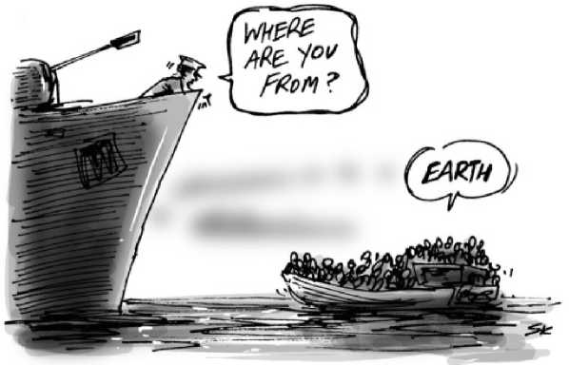

LOCAL ACTION

CONTACTS

Asylum Help

Asylum Help, part of the Migrant Help organisation, provides free independent advice and guidance to asylum seekers across the UK.

Phone: 0808 8000 630

Website: <http://asylumhelpuk.org/con> tact-us/

**Asylum Link Merseyside (ALM)** ALM offers a range of services and support to asylum seekers.

St Anne's Centre, 7 Overbury Street, Liverpool, L7 3HJ

Phone: 0151 709 1713

Email: [info@asylumlink.org.uk](mailto:info@asylumlink.org.uk)

Website: <http://www.asylumlink.org>. uk/contact.html

Merseyside Refugee and Asylum Seekers Pre & Postnatal Support Group (MRANG)

MRANG addresses the needs of pre and post natal refugees and asylum seekers, including those who were pregnant or had children as a result of rape

37-45 Windsor St, Liverpool L8 1XE Phone: 0151 708 6316

Website: <http://mrang.org.uk/>

HOPE+

Both Cathedrals and the city centre faith communities Community Outreach initia­tive for those in food poverty; with special concern for asylum seekers and refugees. Liverpool Cathedral, St James' Mount, Liverpool L1 7AZ

*Foodbank & advice pantries are open at:* **St Vincent's Church,** St James' Street, Liverpool, L1 5JP - every Tuesday be­tween 12.30pm and 2.30pm

**St Margaret's Church,** Princes Road, Liverpool, L8 1TG - every Thursday be­tween 12.30pm and 2.30pm.

Phone: 0151 702 7237 Mobile: 07973 212137

Email: nadine.daniel@liverpool.angli can.org

Website:<http://www.liverpoolcath> edral.org.uk/home/about-us/hope- plus-food-bank.aspx

and <http://www.hopefoodbank.org.uk>

Support for Wigan Arrivals Project (SWAP)

Support for Wigan Arrivals Project - SWAP - is a community organisation based in the town of Wigan but working across Wigan Borough, including Leigh, Ashton-in-Makerfield, Hindley, Standish, Golborne and the areas in-between. SWAP has a particular focus on helping refugees and asylum seekers.

Penson St, Wigan WN1 2LP

Tel: 01942 614486

For Volunteering opportunities call:

01942 614489

Website: <http://www.swapwigan.org/>

Leigh Asylum Seekers and Refugees Support (LASARS)

LASARS works in Leigh and surrounding areas. At the weekly "Drop-in" (Tuesday 12-3pm) asylum seekers and refugees can get support with a range of queries: housing, job applications, health and so­licitors.

Kingsleigh Methodist Youth Centre, Kings Street, Leigh, WN7 4LR

Website: <https://sites.google.com/site/> lasarsonline/

**Regional Asylum Activism Project** c/o Refugee Action Manchester, Canada House, 3 Chepstow Street, Manchester, M1 5FW.

Landline: 0161 831 5464

Email: [northwest@regionalasylumac- tivism.org](mailto:northwest@regionalasylumac-tivism.org)

Website: [http://regionalasylumactiv- ism.org/](http://regionalasylumactiv-ism.org/)

Twitter: @RAANorthWest

CAMPAIGNING GROUPS Churches Together in the Merseyside Region (CTMR)

CTMR serves as the umbrella body for the main denominations in Merseyside.

Quaker Meeting House,

22 School Lane, Liverpool L1 3BT

Phone: 0151 709 0125

Email: [office@ctmr.org.uk](mailto:office@ctmr.org.uk)

Website: <http://ctmr.org.uk/>

Merseyside Refugee Support Network (MRSN)

An information and support service for local refugee communities and organisa­tions working with and for refugees and asylum seekers.

Works in partnership with LASAR - Liv­erpool Asylum Seeker & Refugee Devel­opment Partnership, and Merseyside Net­work for Change.

1st Floor, St Anne's Centre, 7 Overbury Street, Liverpool, L7 3HJ

Phone: 0151 709 7557

Email: [lasar_mrsn@yahoo.com](mailto:lasar_mrsn@yahoo.com)

Website: <http://www.merseysidenetworkforchange.org/>

Red Cross

Liverpool: Bradbury House, Tower Street,

Brunswick Business Park, L3 4BJ

Phone: 0151 702 5067

Preston: Pittman Court, Pittman Way, Fulwood, Preston. PR2 9ZG

Phone: 01772 707303

Website: <http://www.redcross.org.uk>

Refugee Action

c/o Red Cross, Bradbury House, Tower Street, Brunswick Business Park, Liver­pool. L3 4BJ

Phone: 07917 093159

For help contact Asylum Help on

0808 8000 630

Website: <http://www.refugee-action>. org.uk/in_your_area/liverpool

Roman Catholic Archdiocese of Liverpool - Justice & Peace Commission

J&P Commission, LACE, Croxteth Drive, Sefton Park, Liverpool, L17 1AA

Phone: 0151 522 1080

Email: [s.atherton@rcaol.co.uk](mailto:s.atherton@rcaol.co.uk) Website: <http://www.liverpoolcatholic>. org.uk/Justice-Peace

OTHER GROUPS

Credit Unions - managing your money as a refugee

Credit unions are member-run organisa­tions where members pool their savings so they can lend to one another. This can be a much cheaper way of borrowing money than using banks, and it provides opportunities for saving and getting inter­est. Credit unions are authorised by the Prudential Regulation Authority and reg­ulated by the Financial Conduct Authority and the Prudential Regulation Authority. All deposits in credit unions are protected by the Financial Services Compensation Scheme up to £75,000.

You can find your local Credit Union at: <http://www.findyourcreditunion>. co.uk/home

**Church Credit Champions Network** Email: julia.webster@togetherliverpool. org.uk

Local Authorities

Nationally and politically, responsibility is being given to local authorities and coun­cils to deal with the refugee issue. You can find the contact details for your lo­cal council at: [http://www.gov.uk/find- your-local-council](http://www.gov.uk/find-your-local-council)

Local Charity and Voluntary Services (CVS)

**Liverpool CVS:** <http://www.lcvs.org.uk/> **Sefton CVS:** <http://www.seftoncvs.org.uk/> **Knowsley CVS:** <http://www.kcvs.org/> **St Helens and Halton CVS:** <https://www.haltonsthelensvca.org.uk/> **West Lancs CVS:** <http://www.wlcvs.org/> **Community Action Wirral:** <http://communityactionwirral.org.uk/> **NATIONAL LINKS & ORGANISATIONS**

**Citizens UK:** <http://www.citizensuk.org> **Positive Action In Housing:** <http://www.paih.org/host-a-refugee> **The No Accommodation Network:** <http://www.naccom.org.uk>

**CAFOD:** http://www. cafod.org.uk **Jesuit Refugee Service UK:** http://www. jrsuk.net

**Red Cross:** <http://www.redcross.org.uk/RefugeeCri> sisHero

**Christian Aid:** <http://www.christianaid.org.uk/emergen> cies/

City Of Sanctuary:

<https://cityofsanctuary.org/>

Places of Welcome:

<http://www.placesofwelcome.org/>

FURTHER

INFORMATION

& HELP

More information can be found here:

<http://www.liverpoolasyluminfo.org.uk>



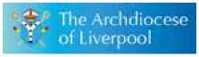

**<L TOG ETHEA** . Archdtoccse of Liverpool

^■A-^,. Liwtpad LIVERPOOL Justice * Peace Loim-mion

Do not forget to entertain strangers, for by so doing some  
people have entertained angels without knowing it."  
Hebrews 13:2

"I tell you the truth, whatever you did for one of the least  
of these brothers of mine, you did for me."  
Matthew 25:40

Published by: Churches Together Merseyside Region  
c/o Archdiocesan Justice and Peace Commission, Liverpool, L17 1AA  
tel: 0151 522 1080 email: [s.atherton@rcaol.co.uk](mailto:s.atherton@rcaol.co.uk)